How to Reverse Engineer Your Competitor's Traffic Sources
Updated: June 30th, 2020
Execution Time: ~10 minutes


Goal: To get an initial overview of your competitor’s traffic sources.

Ideal Outcome: You have an audit that shows you how your competitor’s traffic sources look like.

Pre-requisites or requirements: N/A

Why this is important: Getting a general overview of your competitor’s traffic sources is the first step to reverse-engineer its marketing funnel.

Where this is done: In SimilarWeb.

When this is done: As soon as possible, ideally when you start your business. After that, you should be monitoring your competitor’s moves at least every 3 months.

Who does this: The person responsible for Digital Marketing.

Gather Competitor Traffic Sources data

Before you start: Understand that SimilarWeb does not have access to your actual competitor’s metrics so it relies on multiple partners that provide SimilarWeb with user data insights that are then turned into the estimates you will see in the following reports. This means the results you get in Similar Web will offer you great pointers and insights into your competitor’s strategy, but not necessarily exact numbers.

- Head over to SimilarWeb.com
- Enter your competitor’s domain in the search box:
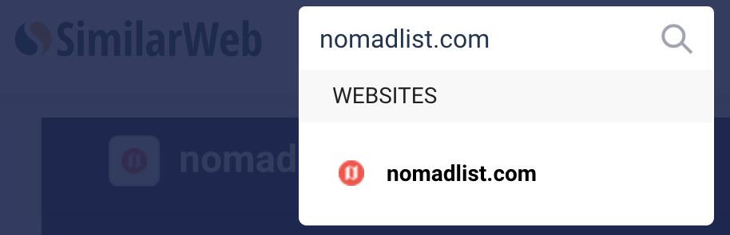

- You’ll get an estimate of how much traffic they’ve been getting over the last 6 months along with some superficial engagement metrics:
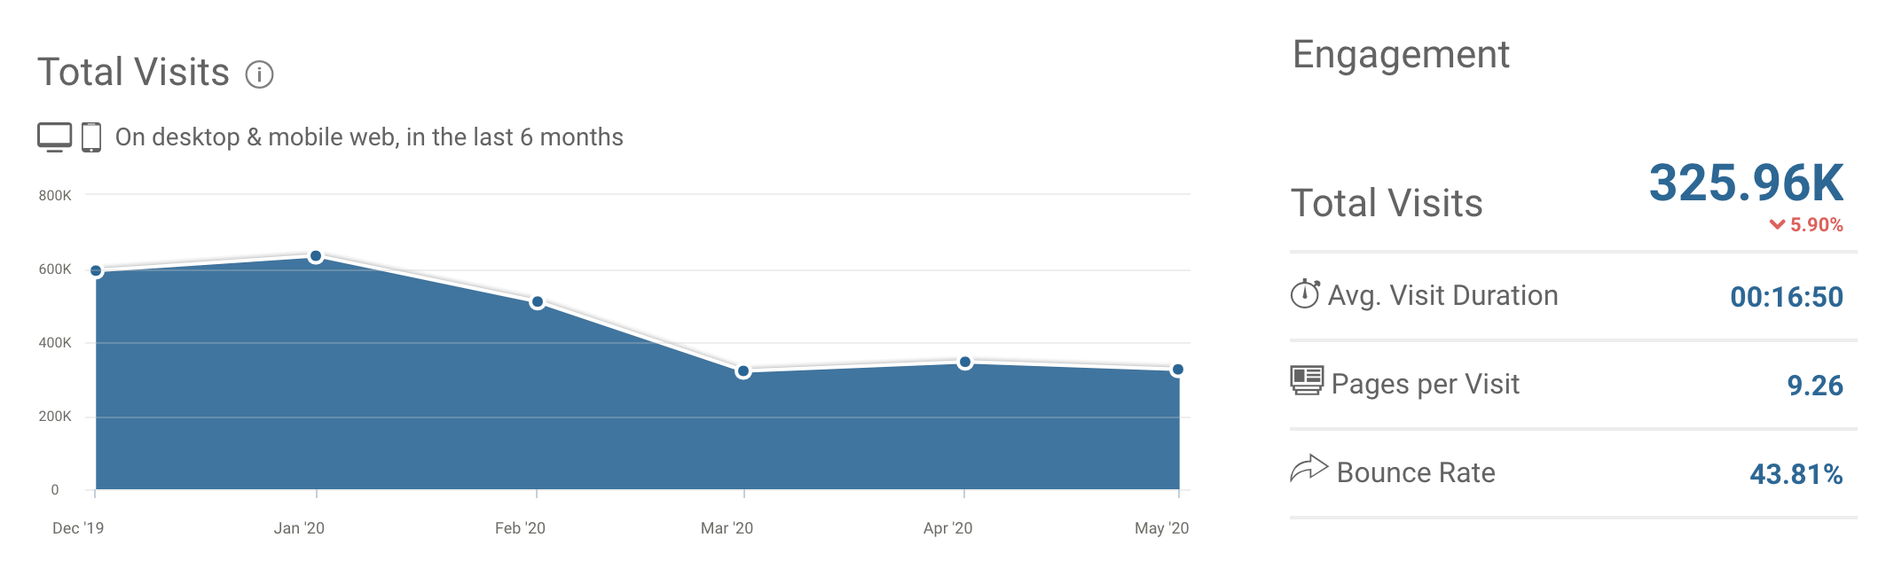

- Scroll down to check which countries are driving the most traffic.
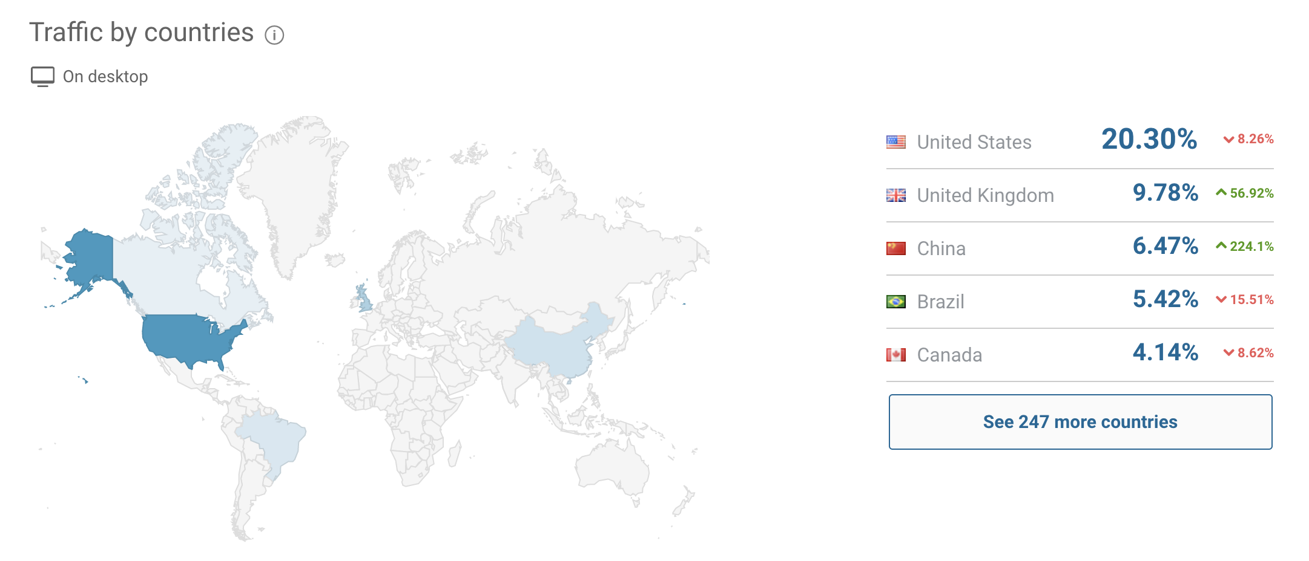

- Scroll down to check the % of traffic driven by each channel:
Note: This is how SimilarWeb classifies each traffic source:

- Direct Traffic –traffic sent from users via URLs entered directly into a browser, saved bookmarks or any links from outside the browser (e.g. desktop software such as on Microsoft Word)
- Mail Traffic – traffic sent from web-based mail clients
- Referral Traffic –traffic sent via links from other domains that are not otherwise classified (mail, social, display, search)
- Search Traffic –traffic sent via the results on search engines such as Google or Bing
- Social Traffic –traffic sent from any social media sites such as Facebook or Reddit
- Display Ad Traffic – traffic sent from other domains via a known ad-serving platform (i.e. Doubleclick) (Source: SimilarWeb)
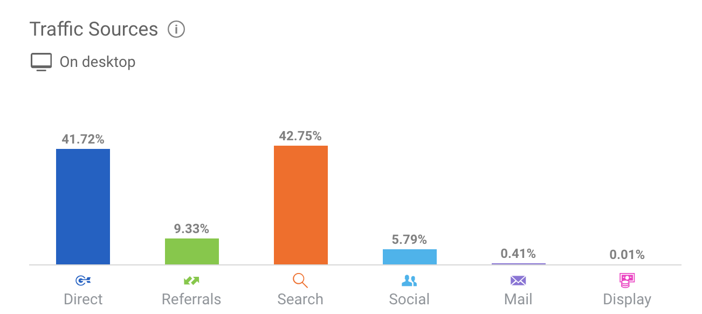

- Scroll down to the Referral section:
Note: This section tends to not be extremely accurate. Use it as an additional data point.
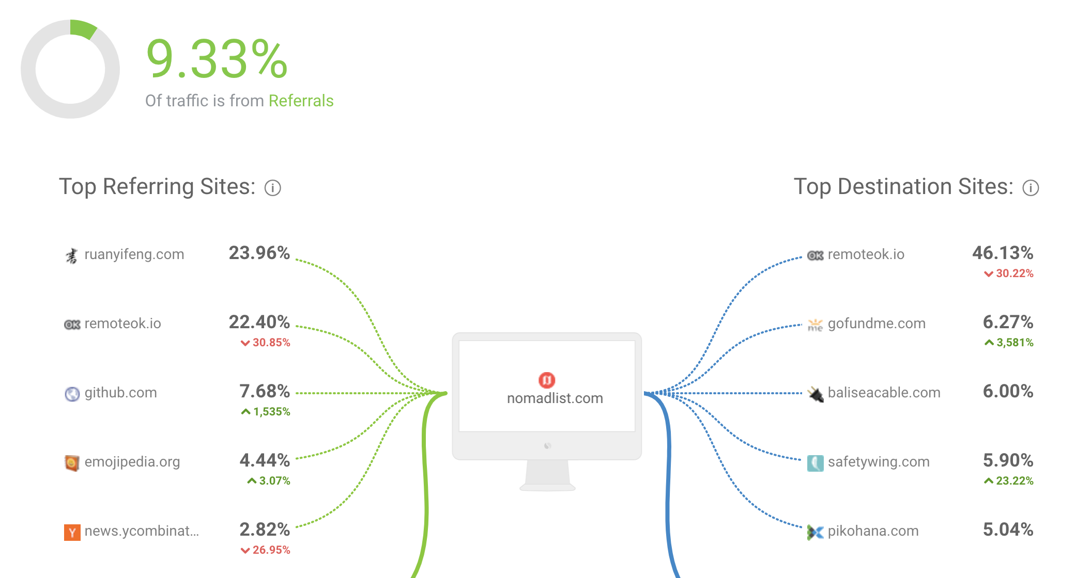

- Scroll down to the Search section to find the top 5 keywords that SimilarWeb believes are the most important to your competitors.
- Scroll down to the Social section to find a distribution of your competitor’s social traffic.
  - Note: If you’re curious to know how much a specific social channel contributes to your competitor’s total traffic you can simply multiply the percentages.
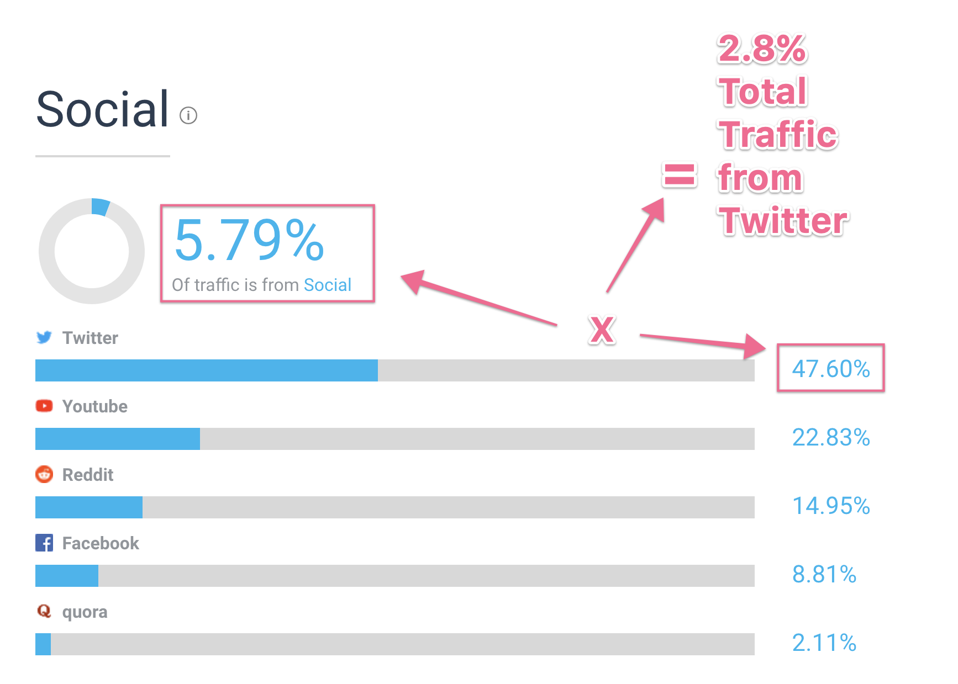

- Scroll down to the Display section to find an overview of your competitor’s Display Advertising Networks and Publishers.

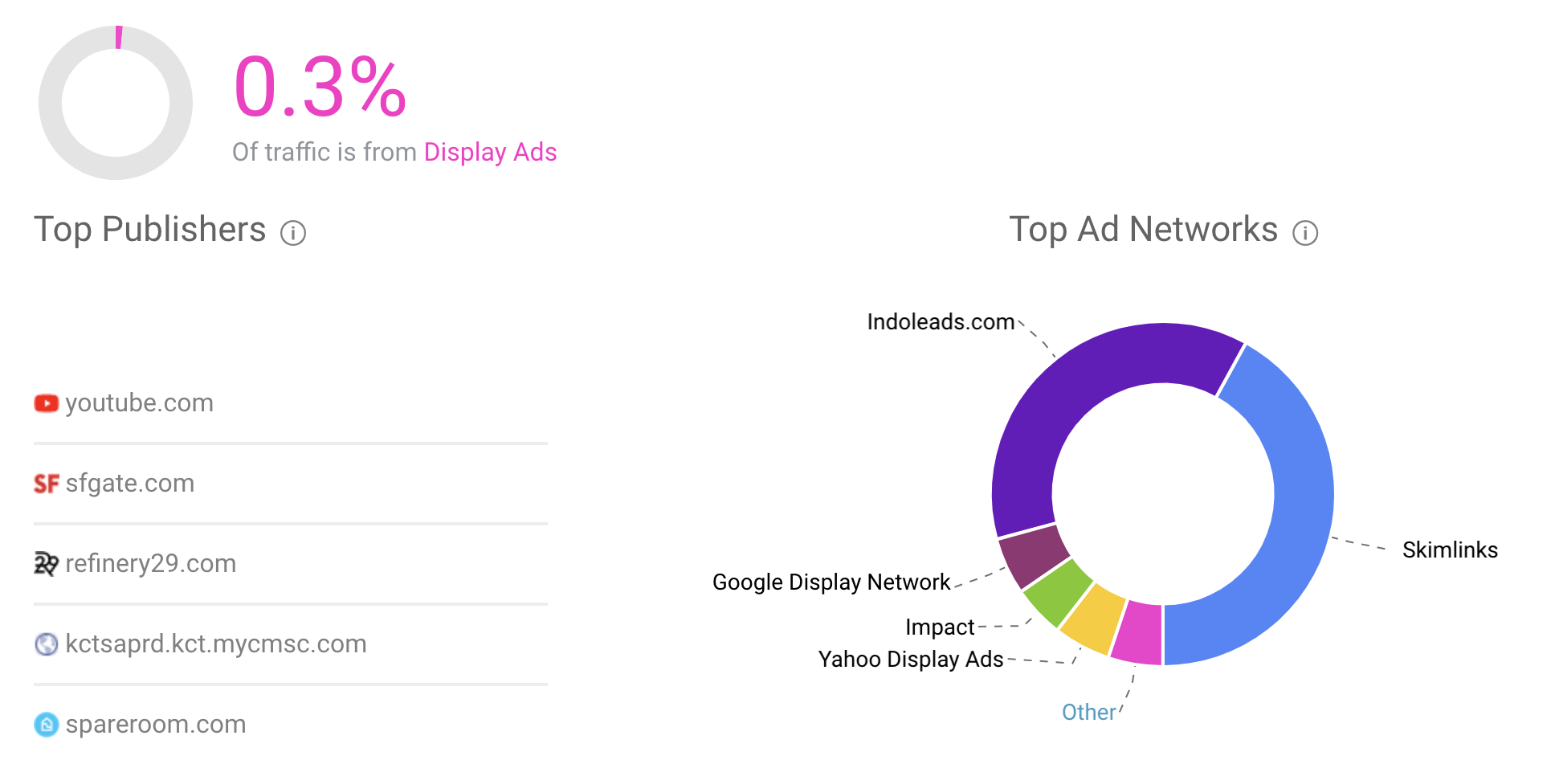

- Scroll down to the Audience Interests section to learn about how their audience might look like.

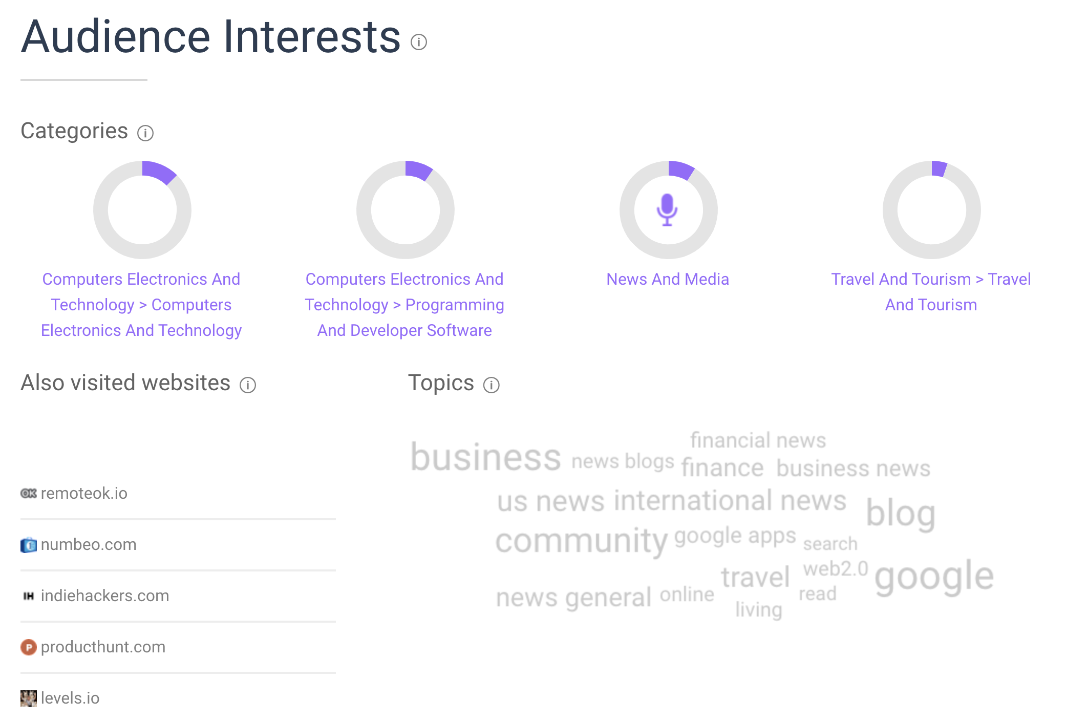

Summarize your findings into an audit report

- Having been through your competitor’s overview on SimilarWeb, summarize the data you collected:

- Main Traffic Sources: What are the top 3 traffic sources for your competitor and what share of their traffic do they represent?

Example:
Brand: Wish.com

Direct: 45%
Search: 41%
Social: 10%

- Traffic Volume: How much traffic did they receive over the last 30 days? Did they experience major growth/decline over the past 6 months?

Example:
Brand: NomadList.com

Comment: ~300K Visits over the last 30 days, big drop starting in March (600K → 300K)

- Engagement Metrics: What are the top 3 countries and which share of the traffic do they represent?

Example:
Brand: NomadList.com

#1 - United States - 20%
#2 - United Kingdom - 10%
#3 - China - 7%

- Engagement Metrics: How much do visitors interact with their website?

Example:
Brand: NomadList.com

Avg Visit Duration: 2 minutes
Pages per Visit: 3.44
Bounce Rate: 55%

- Social Networks: What are the top 3 social networks and how much do they represent to their overall traffic?

Example:
Brand: Booking.com

Facebook - 1.4M / month
Youtube - 500K / month
VK - 45K / month

- Interests: What are their visitors generally incrested in?

Example:
Brand: Booking.com

#1 - Travel and Tourism
#2 - Computers & Electronics
#3 - News & Media

- Publisher Networks: Which networks are they using? What kind of networks are they?

Example:
Brand: Booking.com

Awin - Affiliate Network
DoubleClick - Display Network
SkimLinks - Affiliate Network

That’s it! You now have a comprehensive overview of your competitor’s traffic sources.

